Escape This - map creation tool proposal

# Description / overview

I would like to create a map creator/editor tool to assist players from the Escape This community. Anyone will be able to create and edit their own map/s using my application for windows.

Users will be able to create maps by first defining a map size via a popup dialog, then they will be able to use the tab system on the left to drag and drop items onto the map. Items represent all possible enemies, obstacles, goal entities, etcetera, thus, there is a finite number of items that can be utilized.

Users can also load in other user’s maps or maps from the game and edit them to their liking.

# Functionality

* Drag and Drop items on map placement
* Hover information for each item type
* Item tab system
* Search form
* Map resizing
* Map Breakdown Information
* Multiple map editing, multiple documents
* Map loading

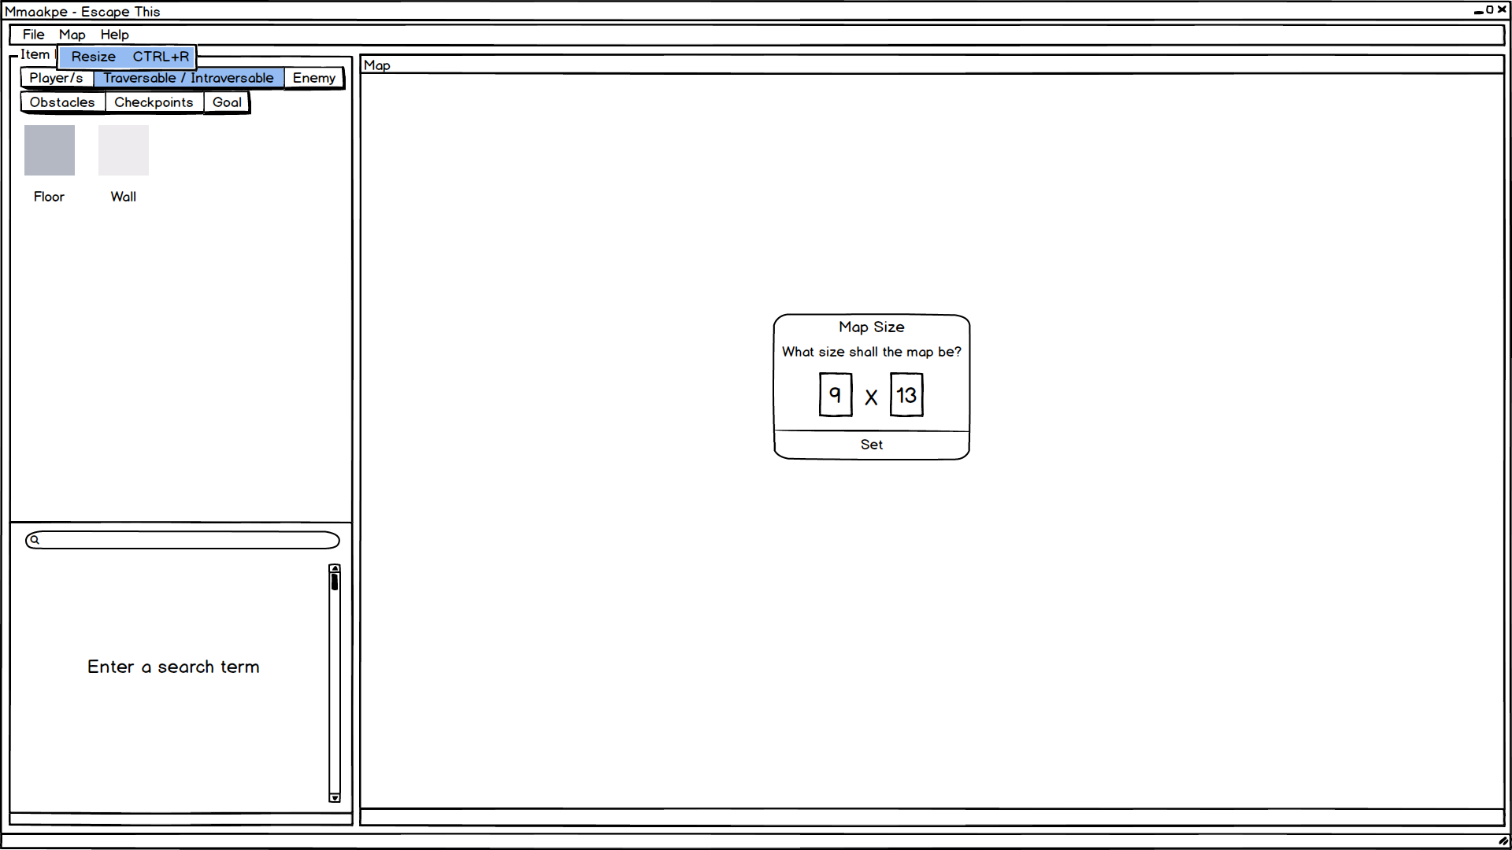

(You are able to resize the map whenever you please, via the file menu.)

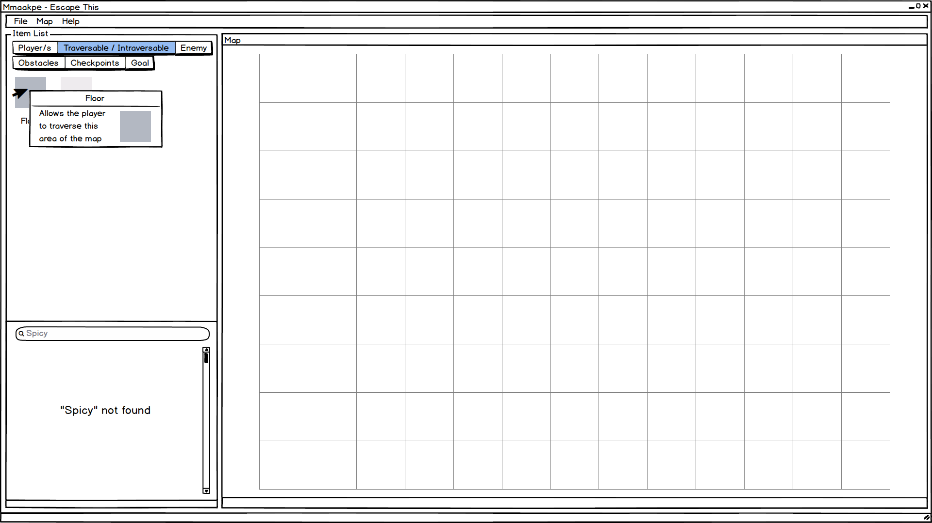

(Hover over items for more information)

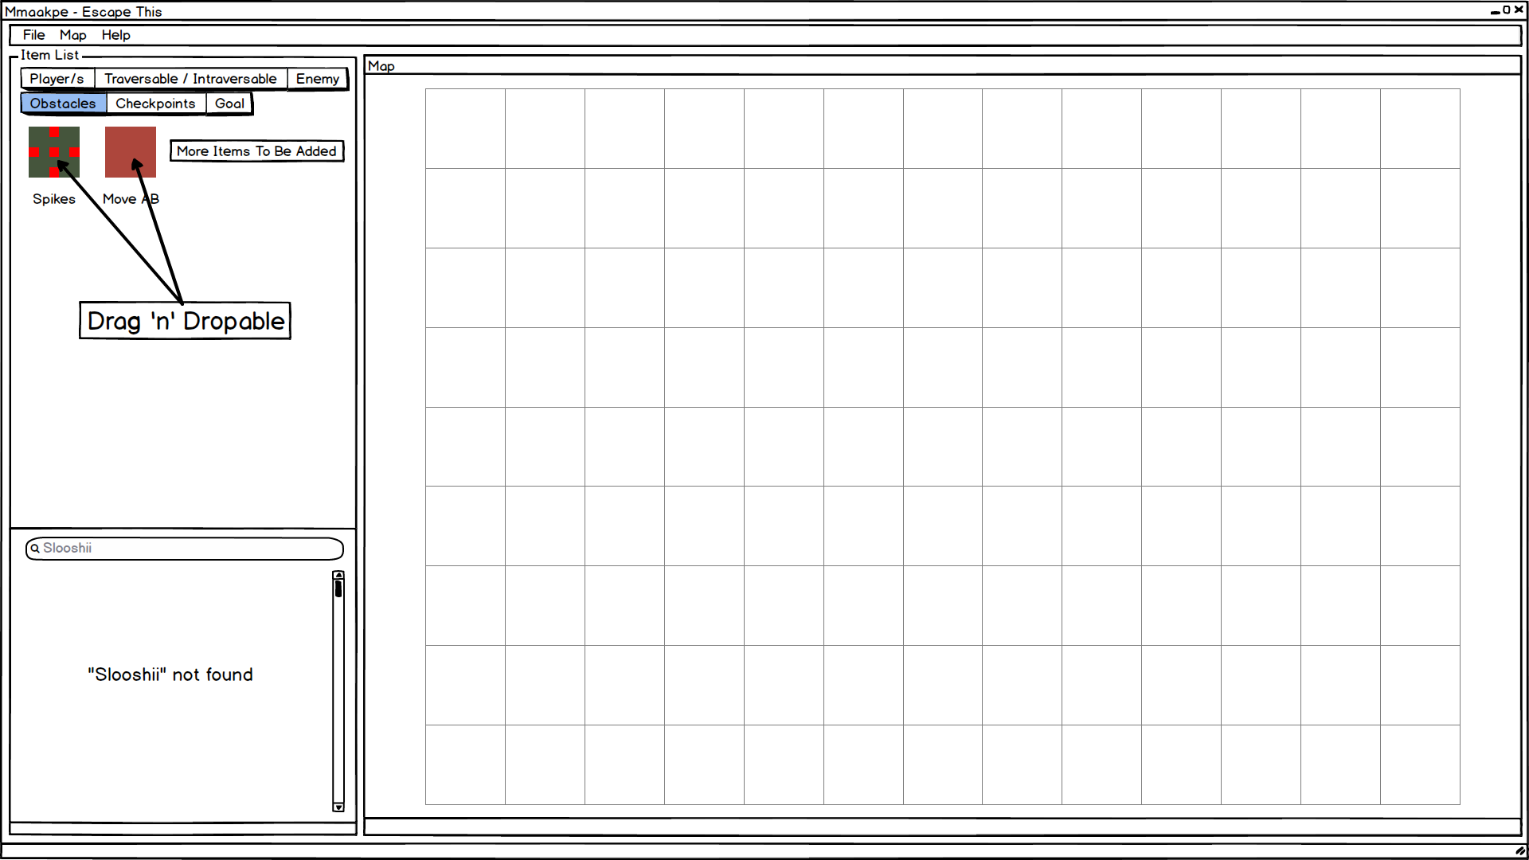

(You can drag and drop items onto the map)

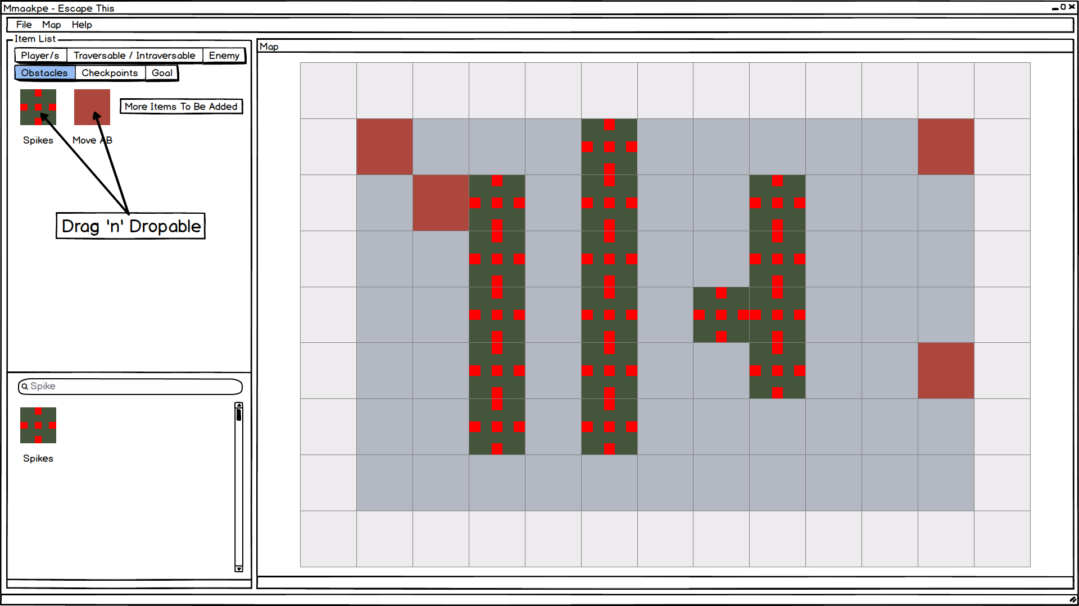

(Map after items have been dragged and dropped)

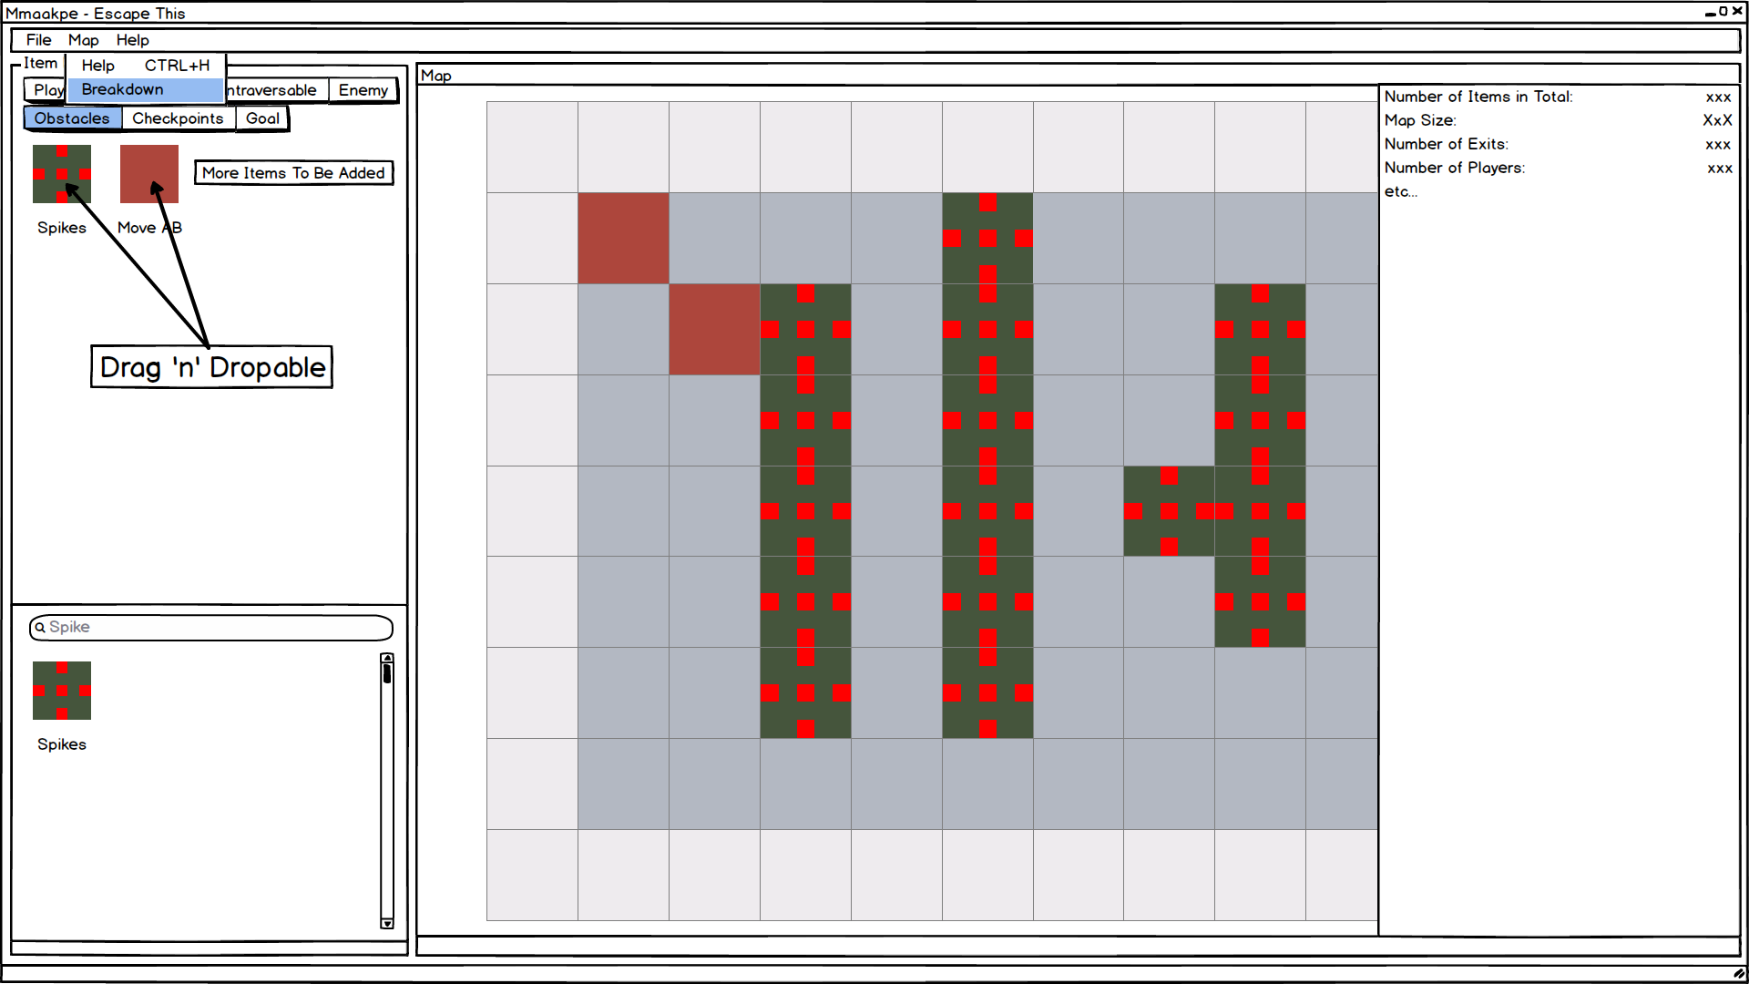

(Users can see the maps contents broken down)

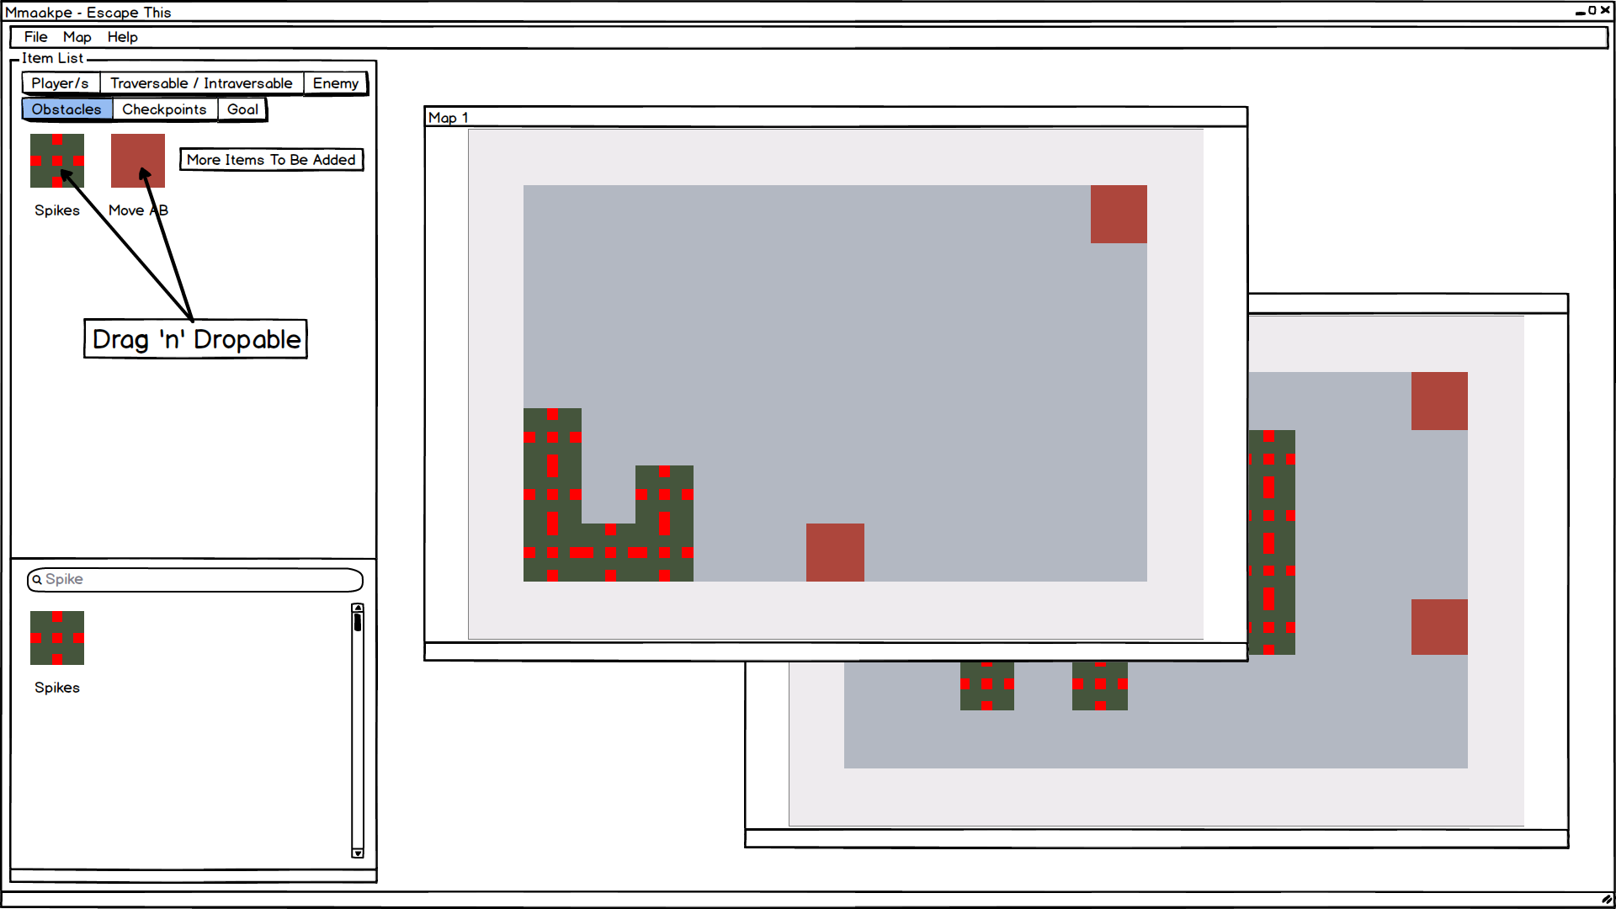

(Users can edit multiple maps at once!)

# Implementation

* Pictures that represent each item are displayed on the left side ordered into categories and are drag and droppable onto the map area. They will snap in place and are added to the export task.
* When you hover your mouse over any item, it will display information about that item.
* Items appear in tabs which are clickable and editable, each tab contains items that relate to the title of that tab.
* Search form, you can search for any item in the game by entering a search term within the search bar.
* Map resizing, at any time (whilst creating a map) you can navigate to the top left of the screen where you will find a map tab, in which you can select resize from, which will resize the map to your specified parameters.
* Map breakdown, users can view debug information about the map through the “Breakdown” context menu entry found under the “Map” context menu.
* Multiple documents can be open at once, allowing for the user to edit multiple maps at once.
* When you select load from the main menu, you can load in a txt file and the program will attempt to display it. If it is compatible it will display the map, if not it will alert the user that the map file is using incorrect syntax.

# Constraints / difficulties

Learning C#, lack of knowledge.

Loading in maps, programming the program to be able to read map files.

Two and a half weeks left, little time.

Snapping to the map grid, when you place a tile it should snap to the map grid, I think this will be hard to achieve.

Exporting to a txt file, I believe that it will be tough to figure out how to export to a txt file format.

Making the elements of the program resize when the windows is resized, properly.

Drag and drop implementation will be difficult, it is a stretch goal at this point.

Hover for information, I want the little information window to follow the mouse properly.

Rendering of layers over other layers, whilst dragging and dropping, whilst hovering for information.

Using Microsoft’s API library to implement API in my project, first time using the Windows Forms C# API.

Figuring out how to allow for multiple documents to be edited at once.

# Minimum viable product

At the very least users should be able to: create a new document, the map size will be 15x15, select items from a panel located at the left side of the interface, then click on a map spot to place the selected item there, be able to erase items from the map, be able to save the map and load it again.

A State Diagram of My Program

